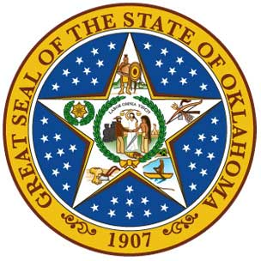
Oklahoma District Attorneys Council

VOCA Grant - Periodic Certification

Agency Name:

Federal Award or Subgrant Number:

Certification
The person whose signature appears below hereby certifies for the period of
(mm/dd/yy) through (mm/dd/yy), (employee name) worked solely on the above
award or subgrant with salary and wages 100% supported by the federal award or subgrant number listed above.
Employee Signature ______________________ Date ______________
or
Supervisor Signature ______________________ Date ______________
Only the Supervisor having first-hand knowledge of the work performed by the employee may sign instead of the employee.

This form meets the requirements of Title 2 Code of Federal Regulations (CFR) Part 225, Cost Principals for State, Local, and Indian Tribal Governments, Appendix B, Selected Items of Costs, for documenting time and effort reporting.
Periodic Certifications must be signed and filed after each six month period of employment. One form is required for each 100% VOCA funded employee.
After completion of each form, please upload into OKGrants for the Subgrant Number listed above.

